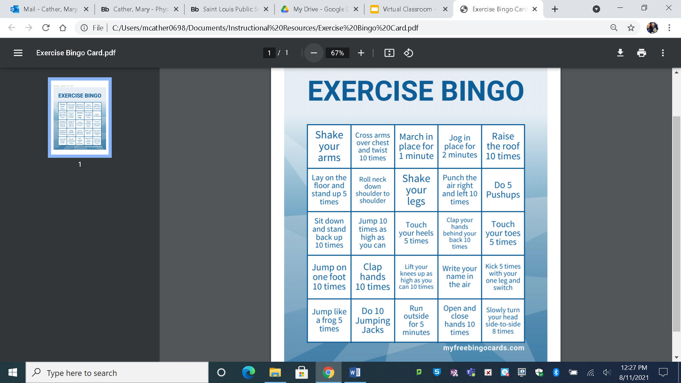Perform the exercises of your choice from the boxes below. If no number of repetitions is stated in the box, perform the activity for 20-30 seconds. Place an X in the box after you complete the exercise. Keep working until, you have 5 X’s in a row. (Up/Down, Across, Or Diagonally)